**Test Result Report Team #3**

**for**

[**TravelWorse**](https://travelbetter.app)

**Version 6.0**

**25/09/2021-28/09/2021**

**Table of contents:**

1. **Introduction**
2. **Testing process description**
3. **Summary**
4. **Testing time**
5. **Test status**
6. **Recommendations and conclusions**
7. **Introduction**

The purpose of this document is to report on the work done on the TravelWorse application, which is being tested by Team No. 3 as part of a training project.

The Travelworse app is a planner of upcoming trips. The team finished working on the requirements, test documentation and started testing. The team has established a communication process, the roles in the project are distributed. In order to quickly answer any questions that arise or share an idea with colleagues, a chat was created in the messenger, where the main communication of the team takes place.

1. **Testing process description**

The requirements were tested by the team. The questions were compiled for the product owner and the answers were received. Based on the responses, the team members made changes to the requirements. Test documentation was created, entered into TestRail, and the team started testing.

When testing a project, the team adheres to the test plan - the Team of the Test Plan No. 3

When testing a project, the team adheres to the test plan - The [Test plan Team#3](https://docs.google.com/document/d/1jFq5OmjdqfJryo0dSRAnOkeyGLdV72ZOxN2FQ1pMLFU/edit)

1. **Summary**

Test status: **YELLOW**

The team completed the work on the test documentation in the TestRail web application and began testing the project application. Despite the fact that testing has begun, there is a risk that it will not be possible to finish the project on time.

1. **Testing time**

| **Full name** | **Date** | **Description** | **Duration, h** |
| --- | --- | --- | --- |
| Ilya Dyuzhev | 25.09.2021 | Working with TestRail | 1 |
| Ilya Dyuzhev | 25.09.2021 | Working with test documentation | 4 |
| Ilona Victorchyk | 25.09.2021 | Writing test documentation | 4,5 |
| Irina Milushkina | 25.09.2021 | Writing test documentation | 5 |
| Ekaterina Drabskaya | 25.09.2021 | Writing test documentation | 4 |
| Ekaterina Drabskaya | 26.09.2021 | Writing test documentation | 3 |
| Ilona Victorchyk | 26.09.2021 | Writing test documentation | 5 |
| Irina Milushkina | 26.09.2021 | Writing test documentation | 6 |
| Ilya Dyuzhev | 26.09.2021 | Working with test documentation | 5 |
| Ekaterina Drabskaya | 27.09.2021 | Working with test documentation | 6 |
| Ilona Victorchyk | 27.09.2021 | Working with test documentation | 5 |
| Irina Milushkina | 27.09.2021 | Working with test documentation | 7 |
| Ilya Dyuzhev | 27.09.2021 | Working with test documentation | 9 |
| Ilya Dyuzhev | 27.09.2021 | Working on the strategy | 1,5 |
| Ekaterina Drabskaya | 28.09.2021 | Working and writing with test documentation | 4 |
| Ekaterina Drabskaya | 28.09.2021 | Testing | 3 |
| Ilona Victorchyk | 28.09.2021 | Working and writing with test documentation | 3 |
| Ilona Victorchyk | 28.09.2021 | Testing | 3 |
| Irina Milushkina | 28.09.2021 | Working and writing with test documentation | 4 |
| Irina Milushkina | 28.09.2021 | Testing | 3 |
| Ilya Dyuzhev | 28.09.2021 | Working and writing with test documentation | 8 |
| Ilya Dyuzhev | 28.09.2021 | Working on the strategy | 1 |

1. **Test status**
2. Requirements

The work with the requirements is completed. User stories have been updated and supplemented with information based on answers to questions. At the moment, all team members have completed work with the requirements and they have a completed form.

All requirements in Jira are marked with subtasks as **Done**

The requirements were divided by priority:

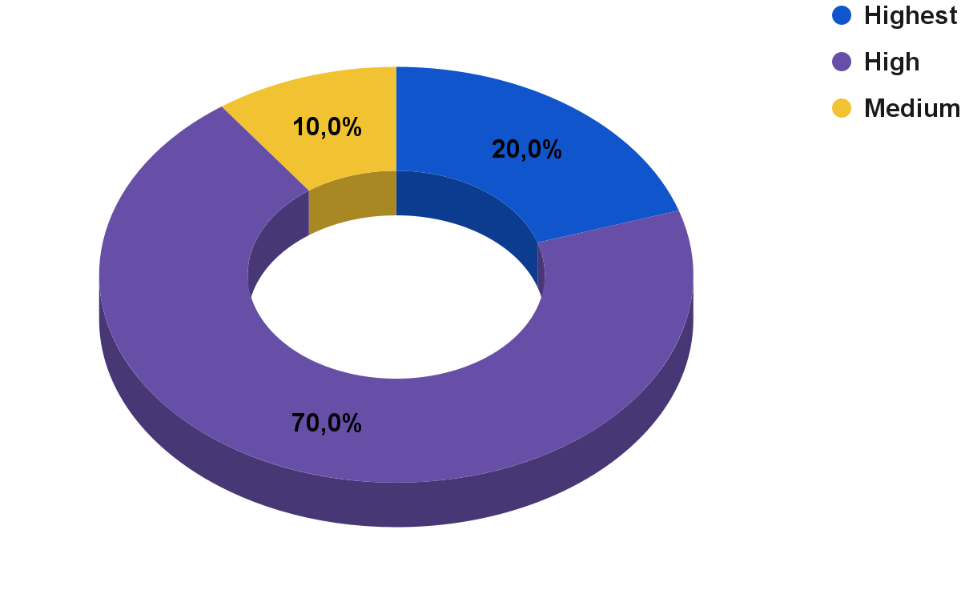

1. Test case creation

The team has prepared test cases for testing in the TestRail program. After completing the work with the requirements, the team set to work on the checklist in order to make test cases based on it.

The team coped with the work on the test documentation in Jira, the subtasks are marked as completed with the status **Done**

The checklist items were distributed according to the following functional testing areas:

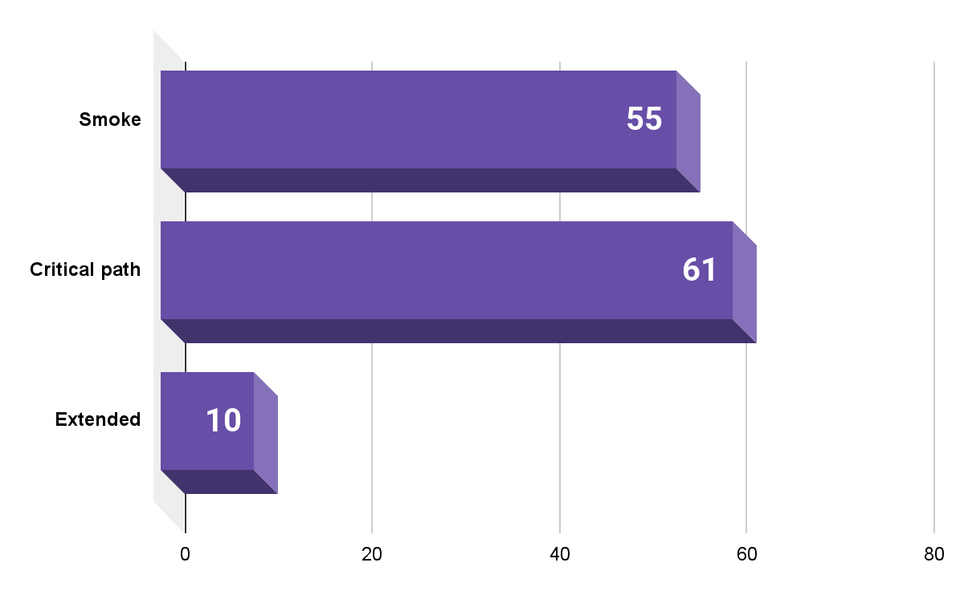

The team has identified almost half of the test cases in the Smoke priority, but this is not quite the right situation. We will review these statuses with the team.

1. By sections, the test cases were divided

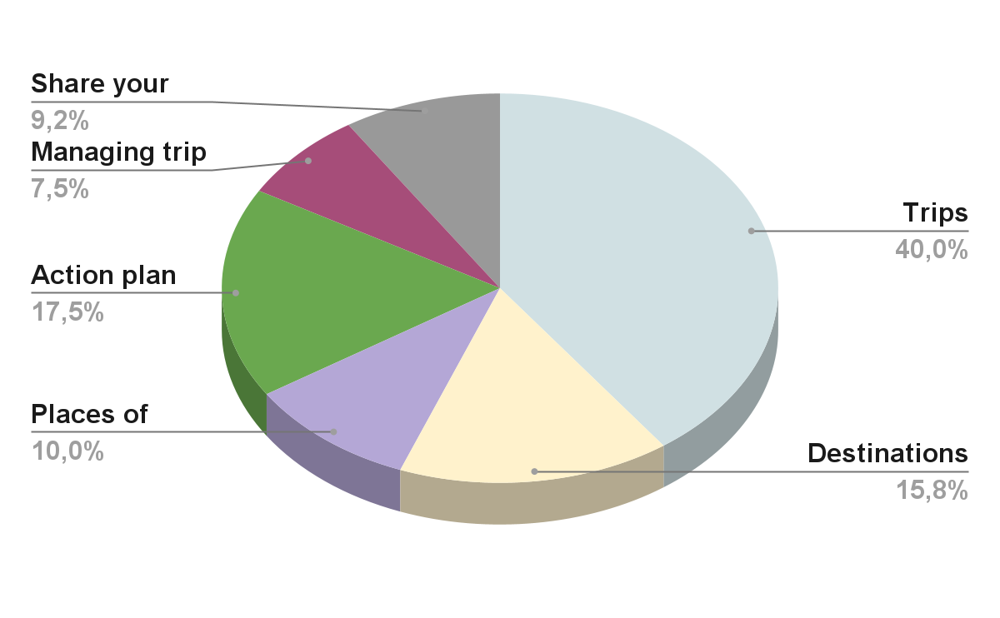

1. Test execution

The team has started testing the application at the time of writing the report.

Detailed information on the test will appear in the next report.

Testing is carried out on three configurations:

* Windows 10 Enterprise x64 (Mozilla 92.0.1.)
* Windows 10 Home x64 (Google Chrome 94.0.4606.61)
* Android 11 (Google Chrome 94.0.4606.61)

1. **Recommendations and conclusions**
2. The team completed all the work with the requirements and was actively working on the preparation of test documentation
3. 126 checklist items were created, which were converted into test cases
4. The team has started testing the application
5. The team has significantly improved its way of working in the Jira application
6. There is a risk of not being able to finish the project on time, but the team will make every effort to complete the full scope of tasks
7. It is strongly recommended to speed up the test process and start looking for bugs as soon as possible